**REG NO. : 412422205009**

**NAME : AKASH RAJ L**

**STEPS TO INSTALL APACHE TOMCAT IN WINDOWS :**

**Step 1:**We need to first install the Tomcat 10 zip file from [this](https://tomcat.apache.org/download-10.cgi" \t "https://www.geeksforgeeks.org/how-to-install-apache-tomcat-on-windows/_blank) website. On the website, select the 64-bit Windows zip (PGP, sha512) in the Core section to start the download process for the Tomcat zip file.

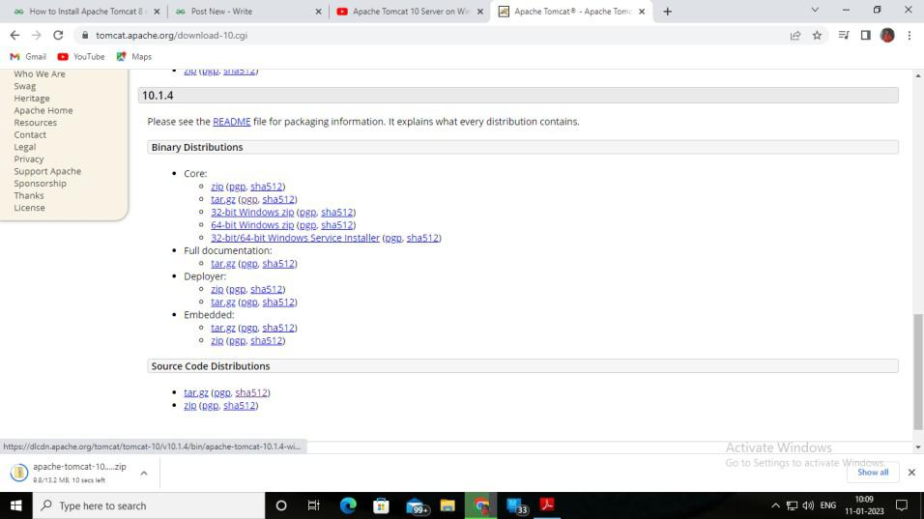

**Step 2: Check If JDK Is Installed.**Open Command Prompt and enter the following commands

*java -version  
javac -version*

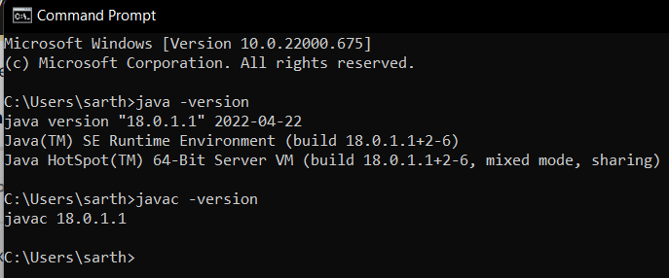

If JDK is not installed on your computer, [install JDK](https://www.geeksforgeeks.org/download-and-install-java-development-kit-jdk-on-windows-mac-and-linux/). In the above picture, we can see JDK is already installed on our computer.

**Step 3: Unzip Tomcat 10 Zip File.**Go to the location where you have downloaded the Tomcat 10 zip file. Right-click on the apache tomcat file place the cursor on 7-Zip and click on Extract Here to extract the folder.

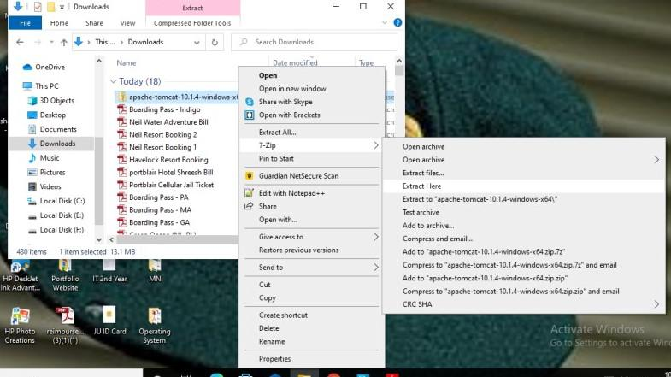

**Step 4: Creating JAVA_HOME Variable.**Click Start then in the search bar, search for “Edit the system environment variables” and click on it. The following System Properties box will open. Select Environment Variables in the box.

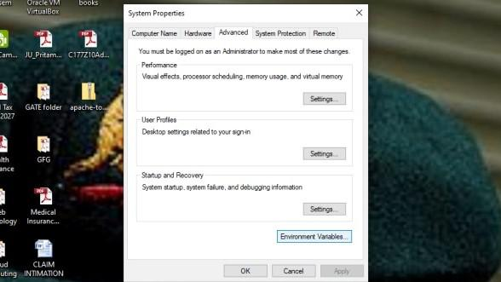

On clicking Environment Variables the following box will open.

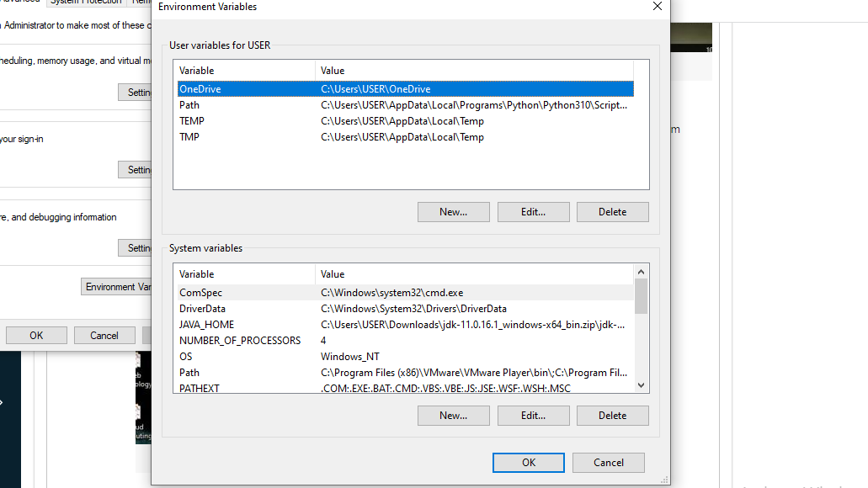

**Step 5:** We have to create a JAVA_HOME variable and insert the path of the JDK file stored in our computer, which will be shown below. So select New from the System variables in the above picture. A New System Variable box will be opened where we will have to fill in the Variable name and Variable value.

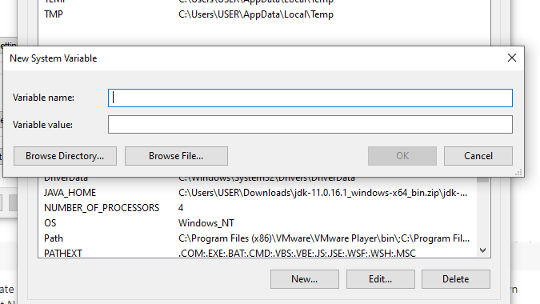

**Step 6:**Go to the location where you have stored the contents of the JDK file in My Computer or PC. Copy the root path of the location of the JDK file as shown below.

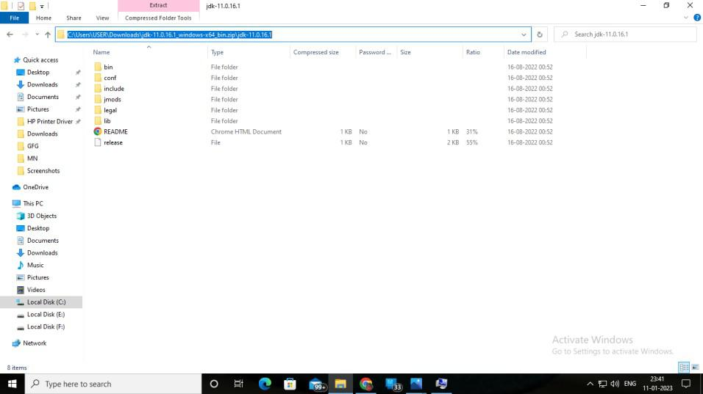

**Step 7:**Paste the JDK path from the above picture into the Variable value field and in the Variable name field, give the name JAVA_HOME as shown below.

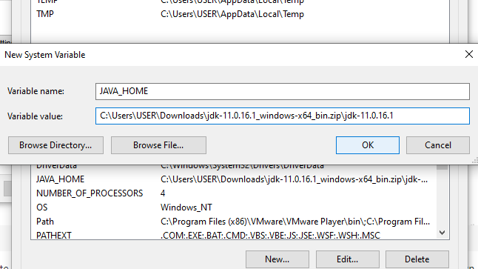

**Step 8: Check the Working of Tomcat.**Open the extracted apache tomcat file. We will see all the following files in them. Among them open the batch file named “startup”.

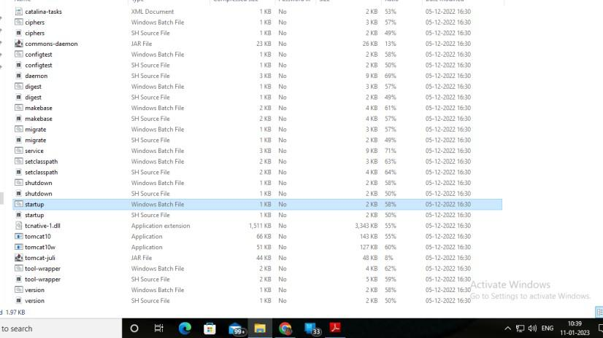

**Step 9:** Check if the Startup Windows Batch File is running properly.

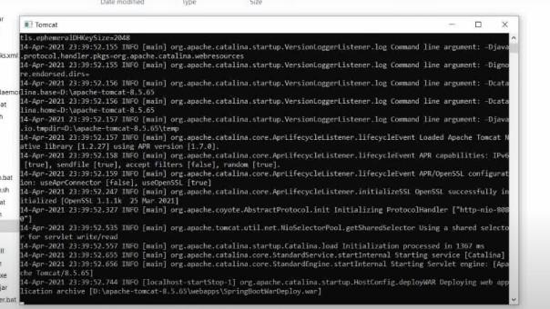

By default, the server port number is 8080.

**Step 10: Successful Installation of Tomcat.**Our next step is to open an internet browser like Google and type in the address

*http://localhost:8080*

Then click enter and the following browser will appear suggesting the successful installation of Apache Tomcat.

